**SQL JOINS**

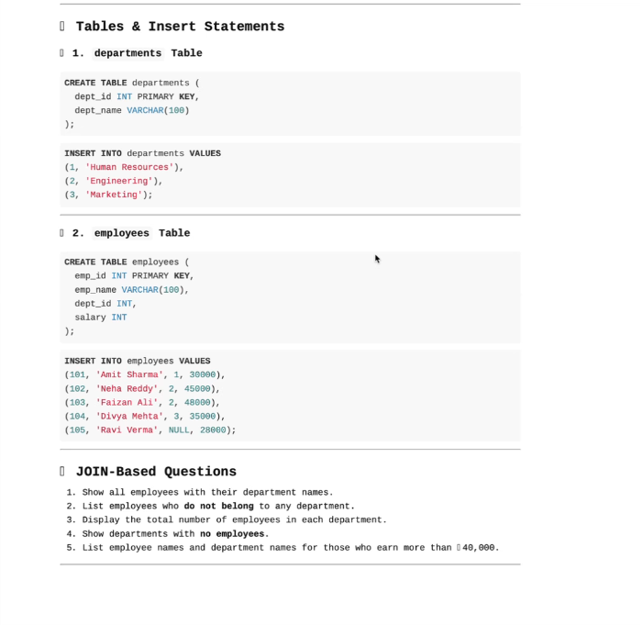

**JOIN BASED QUESTIONS:**

**1.Show all employees with their department names:**

SELECT e.emp_name,d.dept_name

FROM employees

LEFT JOIN departments d ON e.dept_id=d.dept_id;

**2. List employees who do not belong to any department:**

SELECT emp_name

FROM employees

WHERE dept_id IS NULL;

**3. Display total number of employees in each department:**

SELECT d.dept_name,COUNT(e.emp_id) AS total_employees

FROM departments d

LEFT JOIN employees e on d.dept_id=e.dept_id

GROUP BY d.dept_name;

**4. Show departments with no employees:**

SELECT d.dept_name

FROM departments d

LEFT JOIN employees e on d.dept_id=e.dept_id

WHERE e.emp_id IS NULL;

**5. List employee names and department names for those who earn more than 40,000:**

SELECT e.emp_name,d.dept_name

FROM employees e

LEFT JOIN departments d on e.emp_id=d.dept_id

WHERE e.salary > 40,000;